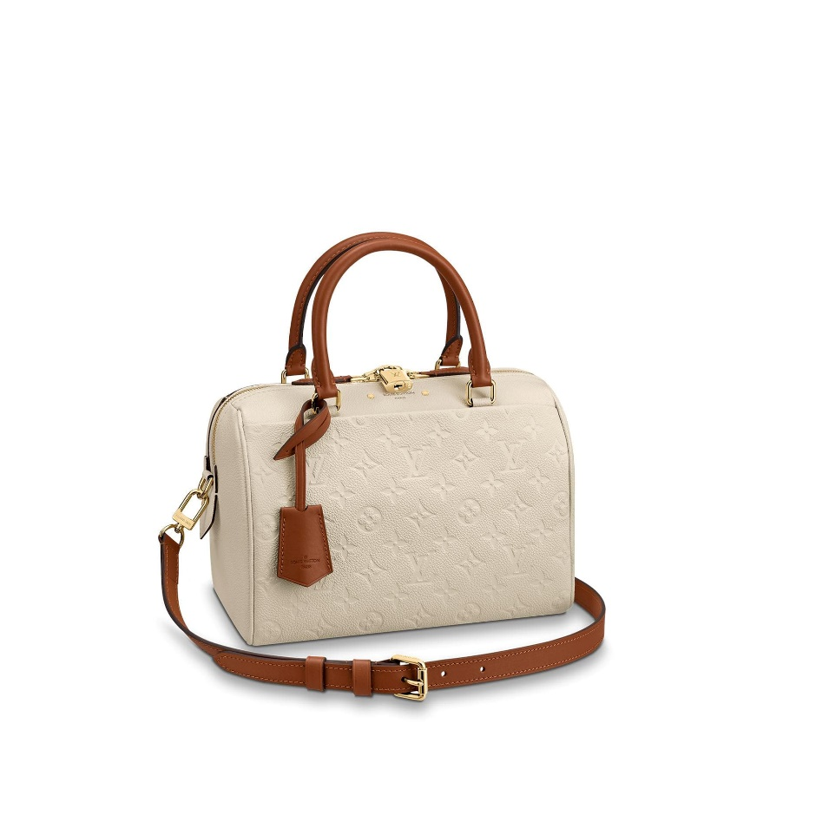

Speedy Bandoulière 25 Monogram Empreinte Leather

PRODUCT DETAILS

**- 9.8 x 7.4 x 5.9 inches**

**- Embossed supple grained cowhide leather and supple grained cowhide leather**

**- Supple grained cowhide leather trim**

**- Removable and adjustable leather strap**

**- Golden colour metallic pieces**

**- Textile lining**

**- 2 inside smartphone pockets**

**- 1 inside zippered pocket**

**- 1 exterior front flat pocket**

**- Double Zip and padlock**

**- 1 Keybell**